REQUIREMENTS ENGINEERING FOR A LOCAL CLINIC MANAGEMENT SYSTEM

Dirghayu KC
International American University (IAU)
CSE220:Principles of Software Engineering
Pratik Bhushal
Oct5,2026
Introduction
A local clinic offers a wide range of vital health care services like patient registration, appointments, medical consultation, disease diagnosis, prescriptions and billing. These activities still continue to be done in a manual process in many of the small clinics where paper forms, registers, notebooks, and physical files are used. This approach is suitable for small numbers of patients, but can be problematic in larger clinics.
This is a process called software engineering which offers a systematic way to build software to satisfy the needs of their users. Kung (2024) stated that software engineering is mainly concerned with increasing the productivity and quality of software- and controlling software development costs and time. A clinic management system, therefore, can help in replacing the inefficient manual procedures with a well-organized and reliable computer-based system.
Understanding the needs of the organization and its users is an important step in the development of such a system, and this is the job of requirements engineering. Elucidation of system requirements is a process of gathering, analyzing, identifying and documenting information received from the requirements stakeholders, necessities constraints, before system development.Requirements elicitation is the process of collecting information from the requirements stakeholders, analysing their needs, identifying systems needs and constraints, and documenting systems requirements prior to system development.
Organization Selected
This case study is done on a local medical Clinic. The clinic provides a general medical consultation and basic health care services to patients. There are a few employees, such as a receptionist, some doctors, some nurses and an administrative/ billing staff member.
Presently, all the works in the clinic are carried out manually. The receptionist writes down the information of the patient in a register or on paper when the patient arrives. All the patient's previous healthcare data is noted on a physical file. The appointments go in an appointment book and the billing info is kept in a separate book.
The proposed system will be a Clinic Management System (CMS), which will automate patients enrollment, record of appointments, patient records, information regarding doctor consultation, prescriptions, billing, and the creation of report.
Problem Statement
The clinic suffers from a number of problems in the current manual system. Staff may take a long time to find details on an old record since they have to sift through physical records. Paper records can also be damaged, lost or ineffective to maintain.
There is also an issue with appointment management. Appointments can be double booked, or missed - this is due to manual recording. There's also additional time required for staff to check registers, ensure key times are available for appointments, and review what is and isn't happening.
There's also the potential for mistakes in billing/receivables and record keeping as it relates to manual data entry. The staff need to be able to make calculations and arrange information in daily and monthly reports. These constraints impact efficiency and can hinder management getting timely, accurate information.
So, the clinic needs a system that can securely store data, lessen manual tasks, boost accuracy and make it easier to access key data in a relaxed time.

The proposed system has the following objectives:
The primary goal is to create an automated system to enhance the efficiency of the clinic's operations.
Specific objectives are:

- Handling patients' information digitally and keeping it in the system.
- To be able to schedule appointments effectively.
- To enable only designated persons to gain access to patients' health records.
- For the recording of consultation and prescription information.
- To create bills and keep track of bill payments.
- To minimize manual error in entering data.
- To make meaningful reports to clinic management.
- To ensure patient data protected by proper access control.
The goals are based on requirement engineering which is a principle useful in identifying the real world business requirement before assigning detailed system requirement for any business (Kung, 2024).
Requirements Gathering Techniques
Requirements Elicitation is the activity used to gather information from the stakeholders regarding the required information by them in the proposed system. Requirements should be determined after data is gathered and analyzed, according to Kung (2024). Interview, questionnaire, observation, document analysis and brainstorming may be applied to this case study.
Interview
An interview may take place with the clinic reception, doctors, nurses, and clinic administrators.
During a job interview, you might be asked the following types of questions:
- What is your current process for obtaining new patient's signatures?
- In what way are appointments kept?
- What are the strategies you use for locating past patient records?
- What are some of your issues with paper records?
- How bills are prepared.
- What are the data elements that the new system needs to support?
- Are patient records supposed to be available to anyone?

During the interview, in-depth knowledge of the issues that stakeholders faced in the particular context is gained.
Questionnaire
The questionnaire can be provided to all staff working at the clinic to gather information from multiple users in a structured format.
Examples:

Question | Possible Response
Do patients have access to their records? | Yes/No
Are there any clashes of appointments? | Yes/No
Would the use of computer records help to speed up time? | Yes/No
If and why should physicians read through patient records? | Yes/No
Do the system make reports?? | Yes/No

Participants determine common issues and aspirations from users using the questionnaire.
Observation
The analyst has a view of the normal functioning of the clinic. This means watching patient registration, patient appointment recording, doctors accessing medical documents, bill preparation, etc.
Use it for observation – users may not verbalize all of their problems when conducting an interview. The analyst is able to observe the actual flow and work and detect unnecessary tasks, duplicate data entry, delays, etc. in practice.
Document Analysis
Patient registration forms, appointment books, prescription records, bills and daily reports can be analyzed to determine their actual content. These documents are useful to determine the data to be stored in the proposed system.
Brainstorming
Staff and development can participate in a brainstorming session. The participants can propose additional features such as appointment reminders, searching patient history, providing electronic prescriptions, billing, reports, etc., and signing up with the user. The ideas can then be reviewed and prioritized.
Summary of Results of Gathering Requirements
The information collected from the different techniques can be summarized as follows:

Technique | Main Finding
Interview | Staff requires quicker access to patients information.
Questionnaire | Trend to use computer for records rather than paperwork.
Observation | Registration and search is slow by using manual method.
Document Analysis | There are number of paper forms that have redundant data.
Brainstorming | The staff made recommendations for appointments, records, billing, and reports.

These techniques combined give a greater insight into the true needs of the clinic. The more sources you utilize, the less chance there will be of missing the needs of important stakeholders.
Current System Limitations
The current manual system has been found to have the following drawbacks:
Slow Record Searching
It takes time to locate a patient's record since the process involves physically going through files.
Insurance of Missionary Life
Paper records may be misplaced or get lost or damaged, or they may be destroyed.
Appointment Conflicts
The paper based appointment book can lead to double or wrong appointments.
Data Entry Errors
Entering the wrong information into registers or forms.
Difficult Report Generation
All measurements must be manually calculated and organized for the daily report, the weekly report, or monthly report.
Limited Information Sharing
Use of physical records makes it difficult for one staff member to access the information provided by a different staff member.
Security Problems
Authorized people get access to paper records; non-authorized people see or get access to the paper records.
Functional Requirements
Functional requirements gives the description of what the designed system should do (Kung, 2024).
The Clinic Management System should be able to offer the following functionality:
- User Login: Allow authorized users to login with their credentials.
- Patient Registration: Staff shall be able to create new patient records.
- Patient Search: Users will be able to search patients using patient ID or patient name.
- Appointment Management: Receptionists can create, update, cancel and view appointments.
- Examine and edit patient consultation records: Physicians will have access to and manage records of patient consultations.
- Prescription Management: Physicians will have the ability to document medicines and directions.
- Medicines bill checking: System will calculate and record medicines bills to patients.
- Staff will have the facility to record payment information - Payment Records.
- Report Generation: The system will be able to create reports, including daily meetings, patient info, and revenue generation.
- User Management: Administrators shall be able to create new User Accounts and manage it.
Non-Functional Requirements
Non functional requirements are the quality features and limitations of the system – but not any particular function (Kung, 2024).
Security
Only authorized users should be able to access patient information. Various users need to have the correct access rights.
Performance
Search and normal operations in the system should be quick.
Reliability
It should work consistently and it should ensure that there will be a minimum risk of data loss.
Usability
The interface must be very simple and easily understood by receptionist, physicians, nurses and administrative personnel.
Maintainability

System should be programmed with ease for future changes and improvements.
Availability
The system should be up and running during the clinic's time frame, with only minimal downtimes.
Data Backup
Regular backups should be made of important patient and transaction detail to minimise the occurrence of lost data for good.
Proposed System Workflow
The clinic management system job flow, as shown in figure 1, consists of the following main activities:
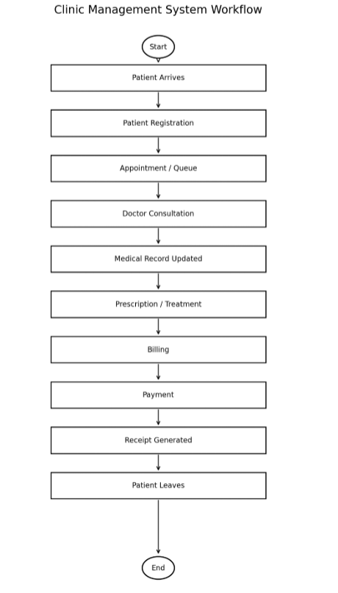

In this workflow, it is shown how information can flow through the proposed computerized system. The system links together activities that are now paper based.
11. Patient Registration Workflow
The Patient Registration Workflow displays the workflow used to register patients if a new patient were to be added to the Clinic Management System. The process starts when the patient arrives and continues through entering personal and medical information. This system then logs the date of the appointment and the doctor assigned. Once this appointment is registered, the system will log the date and doctor that has been assigned to the appointment.
This workflow helps streamline the registration process, mitigates needless human actions, and guarantees that problem-important information is captured in a systematic way. It is one of the most crucial working needs of the intended system (Kung, 2024).
Figure 2. Patient Registration Workflow
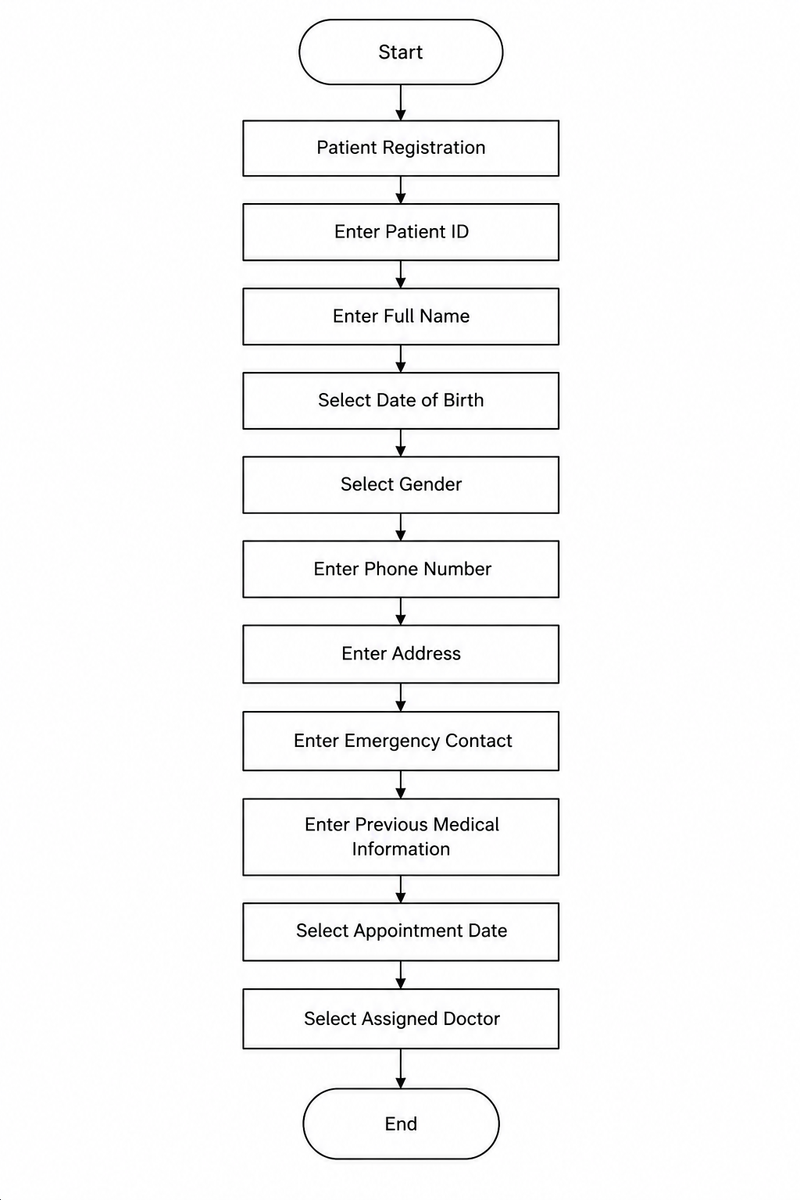

All the following details get added to the workflow: Patient Registration, Patient ID, Full Name, Date of Birth, Gender, Phone Number, Address, Emergency Contact, Previous Medical Information, Appointment Date, and Assigned Doctor. Once all the necessary information is filled out, the registration process is finished.
Expected Benefits
The proposed system can give a number of benefits to clinic. Patient records can be accessed sooner and diminish the time spent looking for them in hard copy records. The scheduling process can be more efficient and minimizing the risk of double booking.
Patient records are easily accessed, allowing doctors to see everything, and the administrative staff can create bills and reports without having to do excessive manual calculations. The system can also enhance the security of the data with the use of user authentication and access control.
The main advantage of the proposed system is that, it will minimize the unnecessary manual work and thus will enhance the overall efficiency and quality of services offered at the clinics.
Conclusion
A case study is presented that illustrates the application of requirements engineering to the development of a computer based system for the clinic where manual methods are being used. Problems are encountered with the existing system as slow record searching, appointment problem, data entry problem, insufficient reportage and security problems.

Interviews, questionnaires, observations, document analysis, brainstorming were used to identify the requirements. Based on the findings, functional and non-functional requirements came forward for proposed Clinic Management System. It is significant to follow a structured requirements elicitation process because the system should be designed based on the actual needs of the stakeholders rather than the needs that they have perceived by designers and developers of the system (Kung, 2024).

Having a well-crafted Clinic Management System can minimize manual duties, boost data precision, create quicker access to records, and enhance the organization's productivity.

References
Kung, D. C. (2024). Software engineering (2nd ed.). McGraw Hill. Book information

